**THINGS I NEED from the Designers:**

**Enemy artwork**

-have a few variations e.g. diff species

-have a few variations of bosses

- If you want to go with the IK system, just give me a Photoshop file with the limbs in separate layers. If not an Idle, Attack and Walk animation is needed. It’s up to you.

**Ambient creatures**

-Literally a static creature, or if possible, a walking animation

-things like insects, firefly’s, snail, other misc. things.

-Look at terraria critters, that’s pretty much what I want. A walking animation and idle sprite if possible?

-https://terraria.gamepedia.com/Critters

-I’m looking for stuff like terraria’s Buggy, frog, mouse, snail, butterfly’s, grubby. Look at the link above.

**Foliage (PLEASE MAKE IN GREYSCALE SO COLOURS CAN BE ADJUSTED IN UNITY)**

-Vines (will give example of what format this is needed as)

-Two variations on grass. (A sway animation is needed e.g. when a player walks through it, or the be played to help create the impression of wind. Just a 4 or 5 frame animation from left to right)

-Two variations of flowers (Sway animation too if possible?)

-Maybe even a tree?

-Any other miscellaneous plants of whatever. Go crazy. Look at the image bellow. We need to talk an discuss what colour the plants will be to fit in with the environment, as currently the tiles are purple but that can change if needed.

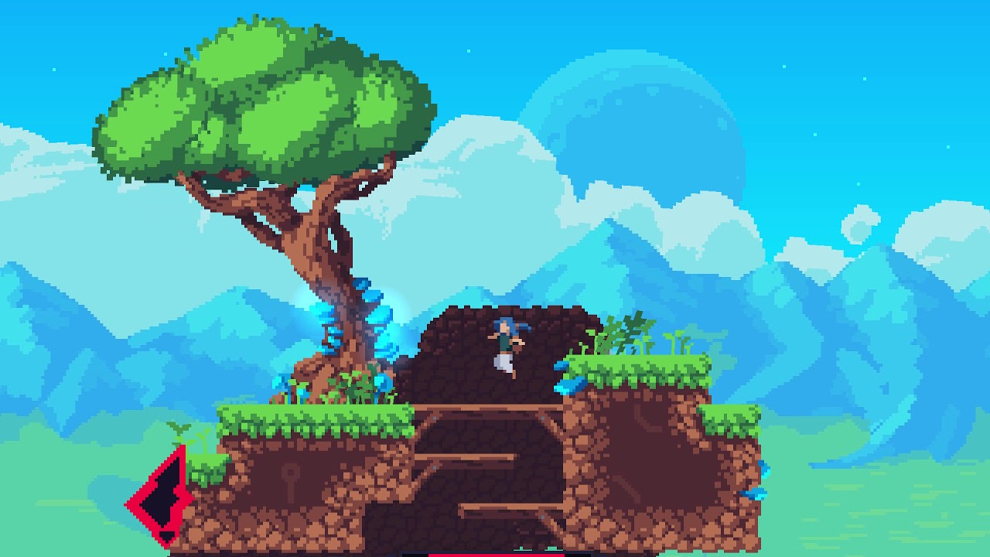

**Level Design (NEEDED AS SOON AS POSSIBLE)**

-Give me a rough layout of what you want it to look like. If you want me to have the level selected from a random list.

-It can literally be a drawing on paper.

-Depending on what goes on I may need to do modifications to the background image. Just send me a design and I can adapt it.

**I need to rest of the art for the options menu. I believe Killian was in charge of this?!**

-Like options menu background or button and stuff

**Animated sprites for projectile attack**

-e.g. arrow for archer or whatever

**Can I have a splash screen explaining controls? I will send you a diagram with what the controls, but I just want something to show the setup and be displayed when the game is ran.**

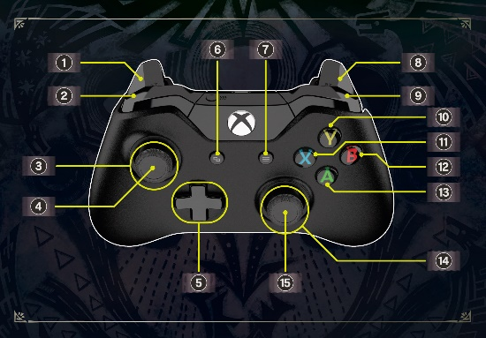

-This kind of thing. But in pixel art and with a solid black background for scaling.

**Perhaps even a logo? Or at least the team name. For a splash screen.**

-make sure it’s a transparent or black background.

**I will send Toby the tile map once I finished it, for modifications. I just spent today making some final changes to make it work better.**

-Also are we sticking to just the one tile set. That’s fine is wanted, but once I finish this file set, I can give you the think and you can literally draw over it to make new ones, so its really easy setup.

**I need sound effects**

-Jump. Run. Attack. Hit. Death

-Ambient noises e.g. enemy noise called now and then? Can be have a squish noise when you run over an insect?

-These can literally be recorded on a phone or something.

**Kilian’s background may need adapting**

-I need to talk about the background, do you want me to make it loop? Keep it static? Scale with camera? I need to do some adjustments to make its height better, but I’ve notices it looks a bit weird bit platform over it. Tell me what to do!